Grazioso Salvare Animal Rescue Dashboard
CS 340 Project Two • Kimberly Ceballos

Grazioso Salvare identifies shelter dogs that may be suitable for search-and-rescue training. This Python dashboard queries the Austin Animal Center Outcomes dataset in MongoDB and presents filterable records, a breed-distribution pie chart, and an animal geolocation map. The interface follows a model–view–controller approach: MongoDB stores the data, Dash widgets display it, and callbacks coordinate queries and updates.

Required functionality
Reset shows all available animal records. A previous Codio connection test retrieved 50,001 records; counts may change.
Water Rescue: Labrador Retriever Mix, Chesapeake Bay Retriever, Newfoundland; intact female; 26–156 weeks.
Mountain or Wilderness Rescue: German Shepherd, Alaskan Malamute, Old English Sheepdog, Siberian Husky, Rottweiler; intact male; 26–156 weeks.
Disaster or Individual Tracking: Doberman Pinscher, German Shepherd, Golden Retriever, Bloodhound, Rottweiler; intact male; 20–300 weeks.
Filtering updates the interactive table, breed pie chart, and geolocation map. The table supports pagination, sorting, column filtering, and single-row selection. The official logo links to SNHU, and the developer’s name appears in the header.

Tools and design rationale
MongoDB stores semi-structured animal records as documents and supports targeted queries by breed, sex, and age. PyMongo provides a Python connection and CRUD interface. Pandas prepare tabular results, Plotly Express generates an interactive pie chart, Dash/JupyterDash provides the web interface and callbacks, and dash-leaflet renders the geolocation map. The AnimalShelter module isolates database operations from dashboard presentation logic.

Reproduction instructions (Codio)
Confirm MongoDB is running and the aac database contains the animal’s collection populated from aac_shelter_outcomes.csv.
Place ProjectTwoDashboard.ipynb and animal_shelter.py in the same directory. Add the official Grazioso Salvare Logo.png file to that directory.
Install dependencies with pip install -r requirements.txt (or use the versions already installed in Codio).
Configure AAC_PASSWORD as an environment variable in the Jupyter server environment, and optionally AAC_AUTH_SOURCE (defaults to aac). Restart Jupyter if necessary so it inherits these variables.
Run all notebook cells. Confirm that MongoDB authentication succeeds and the unfiltered table loads.
Select each rescue filter and reset. Confirm record counts, table, pie chart, and map change appropriately. Select different rows to test the map.

Development challenges and resolutions
During development, MongoDB rejected the initial aacuser credentials with AuthenticationFailed (code 18). The account was confirmed in the aac authentication database and its password was updated in the Codio development environment. A subsequent test authenticated successfully and returned 50,001 records. An earlier CRUD read-method indentation problem was corrected. The dashboard also includes handling for empty filter results and invalid map coordinates. A JupyterDash coroutine warning appeared while the dashboard was displayed; final interactive behavior should still be verified.
Evidence: screenshots to insert after live testing
The following are required screenshots from the running Codio dashboard. Insert real captures showing the official logo, developer name, filter, table, pie chart, and map. They have not been fabricated.

1. Initial unfiltered dashboard
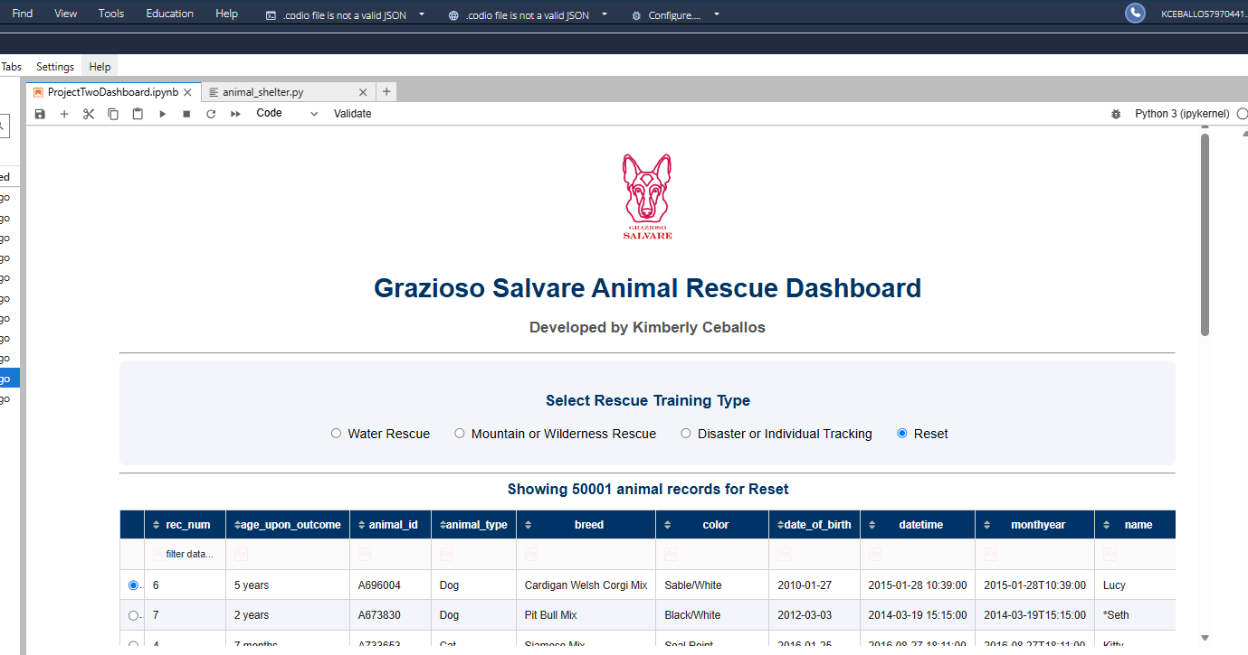
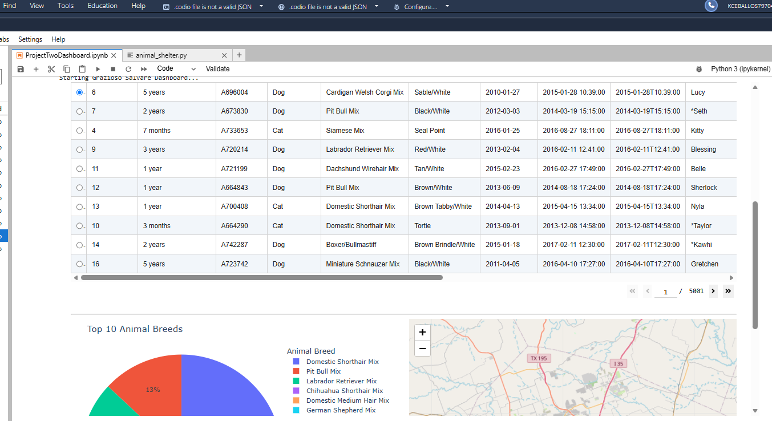
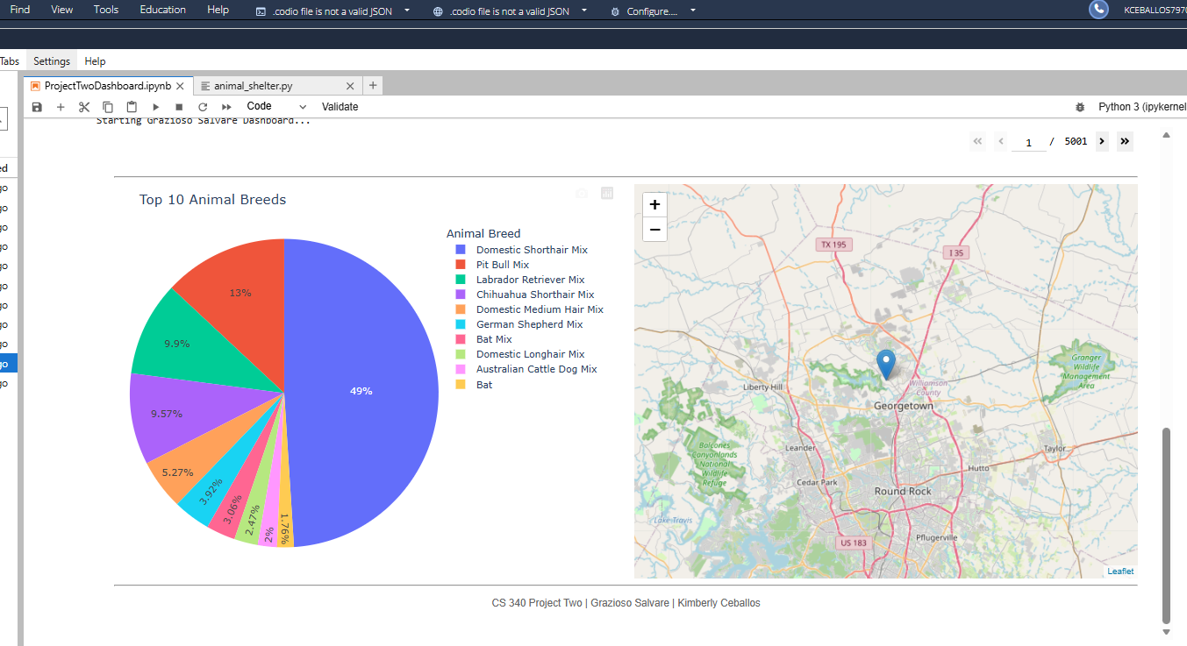

2. Water Rescue selected
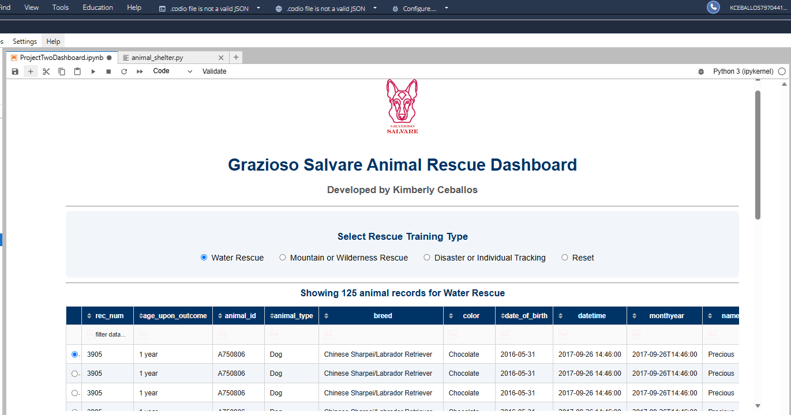

3. Mountain or Wilderness Rescue selected
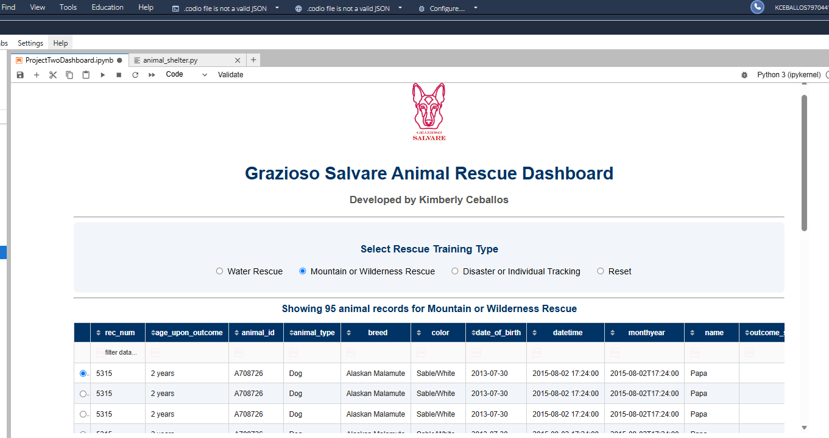

4. Disaster or Individual Tracking selected
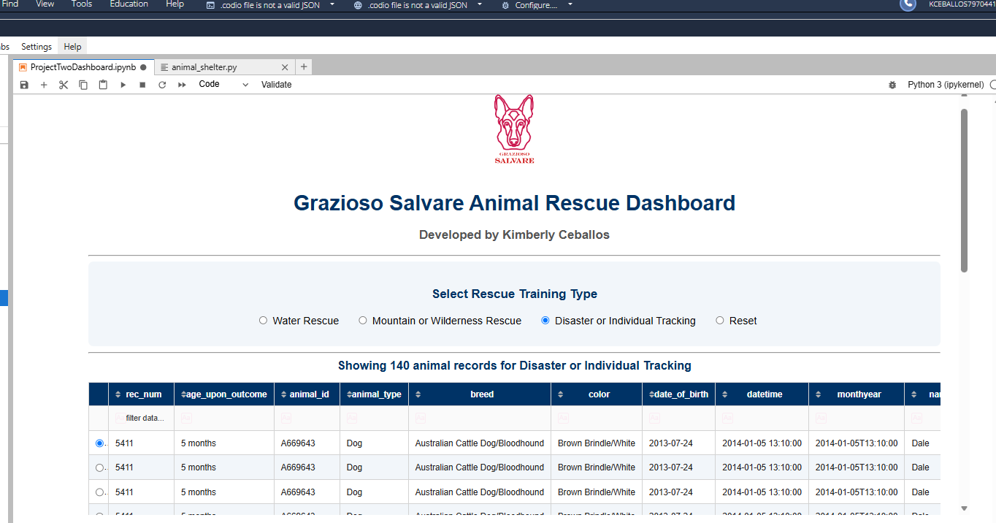

5. Reset selected (unfiltered again)

Known limitations and verification notes
The project has not been executed in this delivery environment against the user’s Codio MongoDB instance. The map focuses on one selected animal (or the first animal with valid coordinates), not every record. The breed regex recognizes the listed breed names and common “Mix” forms, including slash-separated breed components; confirm this interpretation with course expectations. The table sends all matching records to the browser and may be slower for the full dataset. The logo image must be supplied separately. Screenshots are pending live testing.

References and resources
Southern New Hampshire University. CS 340 Project Two Guidelines and Rubric; Dashboard Specifications Document (course materials).
MongoDB documentation : https://www.mongodb.com/docs/
Dash documentation : https://dash.plotly.com/
PyMongo documentation: https://pymongo.readthedocs.io/

